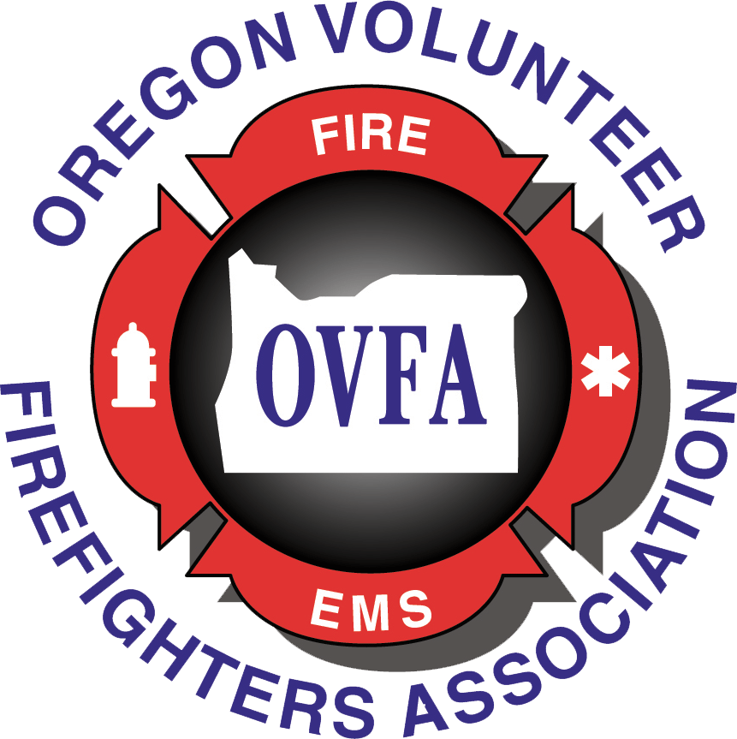**Oregon Volunteer Firefighters Association  
Membership Status (as of 4/30/2025)**

| **Organization** | **2025 Membership Status** | **# Members** | **Dues $** |
| --- | --- | --- | --- |
| Adair RFPD | Current | 11-20 | 135 |
| Amity Fire District | Current | 31-40 | 295 |
| Astoria Fire Department | Current | 1-10 | 50 |
| Aumsville RFPD | Current | 41-50 | 370 |
| Aurora RFPD | Pending | 21-30 | 225 |
| Baker City | Pending | 1-10 | 50 |
| Baker RFPD | Pending | 11-20 | 135 |
| Bay City Firefighters Assn. | Current | 11-20 | 135 |
| Bly RFPD | Current | 1-10 | 50 |
| Breitenbush Fire Department | Pending | 31-40 | 295 |
| Brookings Fire & Rescue | Pending | 21-30 | 225 |
| Brownsville RFD | Current | 21-30 | 225 |
| California Casualty | Current | Sustaining |  |
| Canby Volunteer Fire Association | Current | 21-30 | 225 |
| Cannon Beach RFPD | Pending | 11-20 | 135 |
| Canyon City Fire Department | Current | 11-20 | 135 |
| Central Cascades Fire & EMS | Current | 1-10 | 50 |
| Central Coos Fire & Rescue | Pending | 31-40 | 295 |
| Central Douglas Fire and Rescue | Current | 21-30 | 225 |
| Central Oregon Coast Fire & Rescue | Current | 11-20 | 135 |
| Charleston Fire District | Current | 11-20 | 135 |
| Chiloquin Fire & Rescue | Pending | 21-30 | 225 |
| Christmas Valley RFPD | Current | 11-20 | 135 |
| Clackamas Fire District | Pending | 50-70 | 450 |
| Clatskanie Fire | Current | 11-20 | 135 |
| Cloverdale RFPD | Current | 21-30 | 225 |
| Coburg Fire District | Pending | 21-30 | 225 |
| Cole, Agnim | Current through 2029 | Associate |  |
| Colestin Rural Fire | Pending | 11-20 | 135 |
| Colton RFPD | Pending | 21-30 | 225 |
| Coos Bay Fire Dept | Current | 21-30 | 225 |
| Coquille Fire Department | Pending | 31-40 | 295 |
| Corbett Fire District #14 | Current | 31-40 | 295 |
| Cornelius Fire Department | Pending | 21-30 | 225 |
| Cove RFPD | Pending | 11-20 | 135 |
| Crescent Rural Fire Protection District | Pending | 11-20 | 135 |
| Crook County Fire & Rescue | Pending | 21-30 | 225 |
| Crooked River Ranch RFPD | Current | 11-20 | 135 |
| CTGR Emergency Services | Pending | 1-10 | 50 |
| Dayton Fire District | Current | 31-40 | 295 |
| Dexter RFPD | Current | 11-20 | 135 |
| Douglas County Fire District No. 2 | Now Central Douglas | -- | -- |
| Eagle Valley Fire Department | Current | 11-20 | 135 |
| East Umatilla County RFPD | Current | 11-20 | 135 |
| Echo RFD | Current | 21-30 | 225 |
| Elkton RFPD | Current | 11-20 | 135 |
| Elsie-Vinemaple RFPD | Current | 11-20 | 135 |
| Estacada Rural Fire District #69 | Pending | 51-70 | 450 |
| Evans Valley Fire District #6 | Current | 11-20 | 135 |
| Fair Oaks RFPD | Pending | 11-20 | 135 |
| Forest Grove Fire & Rescue | Pending | 21-30 | 225 |
| Fossil Volunteer Fire Department | Pending | 11-20 | 135 |
| Gaston Fire District | Pending | 21-30 | 225 |
| Gearhart VFD | Pending | 21-30 | 225 |
| Glendale RFD | Pending | 1-10 | 50 |
| Glide RFPD | Current | 21-30 | 225 |
| Greater Bowen Valley RFPD | Current | 1-10 | 50 |
| Greenacres RFPD | Current | 11-20 | 135 |
| Haines Fire Protection District | Current | 1-10 | 50 |
| Halsey-Shedd RFPD | Current | 21-30 | 225 |
| Harbor RFPD | Pending | 21-30 | 225 |
| Hauser RFPD | Current | 11-20 | 135 |
| Hines Fire Department | Current | 11-20 | 135 |
| Hoodland Fire District No 74 | Current | 21-30 | 225 |
| Huntington Volunteer Fire Dept | Current | 1-10 | 50 |
| Idanha-Detroit RFPD | Current | 11-20 | 135 |
| Illinois Valley RFPD | Current | 21-30 | 225 |
| Imbler RFPD | Current | 11-20 | 135 |
| Irrigon RFPD | Pending | 21-30 | 225 |
| Jackson County FD #3 | Current | 11-20 | 135 |
| Jackson County FD #4 | Current | 11-20 | 135 |
| Jackson County FD #5 | Current | 11-20 | 135 |
| Jefferson County FD #1 | Current | 31-40 | 295 |
| Jefferson RFPD | Current | 21-30 | 225 |
| Joseph Volunteer Fire Department | Pending | 11-20 | 135 |
| Keizer Fire District | Pending | 11-20 | 135 |
| Kellogg Rural Fire District | Current | 11-20 | 135 |
| Klamath Co Fire District 4 | Current | 21-30 | 225 |
| Knappa Fire District | Pending | 21-30 | 225 |
| Lake Creek RFD | Current | 1-10 | 50 |
| Lakeside RFPD | Pending | 11-20 | 135 |
| Lane Fire Authority | Current | 51-70 | 450 |
| Lebanon FD | Current | 51-70 | 450 |
| Lewis & Clark FD | Current | 21-30 | 225 |
| Lookingglass RFPD | Current | 11-20 | 135 |
| Lowell RFPD | Pending | 11-20 | 135 |
| Lyons RFPD | Current | 21-30 | 225 |
| Malin RFPD | Current | 1-10 | 50 |
| Marion County Fire Vol Foundation | Pending | 51-70 | 450 |
| Maupin Volunteer FD | Current | 11-20 | 135 |
| McKenzie Fire & Rescue | Pending | 31-40 | 295 |
| McMinnville FD | Pending | 31-40 | 295 |
| Mid-Columbia Fire & Rescue | Non Renewal (no vols) | -- | -- |
| Millington Fire District #5 | Pending | 31-40 | 295 |
| Mist-Birkenfeld RFPD | Current | 41-50 | 370 |
| Mohawk Valley RFD | Current | 21-30 | 225 |
| Molalla RFPD #73 | Current | 51-70 | 450 |
| Monroe RFPD | Current | 11-20 | 135 |
| Moro Fire Department | Current | 1-10 | 50 |
| Mosier Valley Volunteers | Current | 11-20 | 135 |
| Mt Angel Fire District | Current | 31-40 | 295 |
| Myrtle Creek Fire Department | Current | 31-40 | 295 |
| Nehalem Bay Fire & Rescue | Current | 21-30 | 225 |
| Nestucca RFPD | Current | 11-20 | 135 |
| Netarts-Oceanside Volunteer FF Assn | Pending | 21-30 | 225 |
| New Pine Creek RFPD | Current | 1-10 | 50 |
| Newport Firefighters Association | Pending | 11-20 | 135 |
| North Bay RFPD | Current | 21-30 | 225 |
| North Bend Volunteer Fire Department | Current | 11-20 | 135 |
| North Douglas Fire & EMS | Current | 31-40 | 295 |
| North Gilliam RFPD | Current | 11-20 | 135 |
| North Lincoln Fire & Rescue #1 | Current | 21-30 | 225 |
| Oakland RFD | Current | 11-20 | 135 |
| Olney-Walluski Fire & Rescue | Current | 1-10 | 50 |
| Ontario Fire & Rescue | Current | 21-30 | 225 |
| Parkdale RFPD | Current | 21-30 | 225 |
| Philomath Fire & Rescue | Current | 51-70 | 370 |
| Pilot Rock RFPD | Current | 11-20 | 135 |
| Pine Valley RFPD | Current | 11-20 | 135 |
| Pleasant Hill Goshen RFPD | Current | 31-40 | 295 |
| Polk County Fire District #1 | Current | 51-70 | 450 |
| Port Orford Volunteer Fire Department | Current | 11-20 | 135 |
| Powers FD | Pending | 11-20 | 135 |
| Prospect RFPD | Pending | 1-10 | 50 |
| Redmond Volunteer Firefighters Assn | Current | 1-10 | 50 |
| Rockaway Beach Volunteer Fire Dept | Current | 11-20 | 135 |
| Rocky Point Firefighters Association | Current | 11-20 | 135 |
| Row River Fire Response | Pending | 1-10 | 50 |
| Rural Metro Fire Department | Current | 31-40 | 295 |
| Sauvie Island RFPD #30 | Pending | 21-30 | 225 |
| Scappoose Rural Fire District | Current | 21-30 | 225 |
| Scio Rural Fire District | Current | 41-50 | 370 |
| Scottsburg Rural Fire Department | Pending | 11-20 | 135 |
| Seal Rock RFPD | Current | 11-20 | 135 |
| Seaside Fire & Rescue | Current | 11-20 | 135 |
| Shaniko VFD | Pending | 1-10 | 50 |
| Sheridan Fire District Volunteers | Pending | 11-20 | 135 |
| Siletz RFPD | Pending | 1-10 | 50 |
| Silverton Fire District | Current | 71+ | 500 |
| Siuslaw Valley/Western Lane Fire & EMS | Pending | 31-40 | 295 |
| South Gilliam County RFPD/Condon | Pending | 11-20 | 135 |
| St Paul Fire Department | Current | 31-40 | 295 |
| Stayton Fire District | Current | 41-50 | 370 |
| Tangent RFD | Current | 21-30 | 225 |
| Tenmile RFD | Current | 11-20 | 135 |
| Tillamook Volunteer Fire Dept | Current | 21-30 | 225 |
| Toledo Fire Rescue | Pending | 21-30 | 225 |
| Tri City RFPD No 4 | Current | 21-30 | 225 |
| Turner Fire District | Current | 41-50 | 370 |
| Umatilla County FD 1 | Pending | 21-30 | 225 |
| Umatilla RFPD No. 7-405 | Current | 1-10 | 50 |
| Upper McKenzie RFPD | Current | 11-20 | 135 |
| Vernonia RFPD | Current | 11-20 | 135 |
| Warrenton Fire Department | Current | 21-30 | 225 |
| West Side RFPD | Current | 41-50 | 370 |
| Westport Fire & Rescue | Current | 11-20 | 135 |
| Williams RFPD | Current | 11-20 | 135 |
| Winston-Dillard Fire District | Now Central Douglas | -- | -- |
| Woodburn Fire District | Current | 21-30 | 295 |
| Wy'East Fire District | Current | 41-50 | 370 |
| Yachats RFPD | Current | 1-10 | 50 |