
OREGON VOLUNTEER FIREFIGHTER
ASSOCIATION

AMBASSADOR APPLICATION

Please print or type. Do not use initials

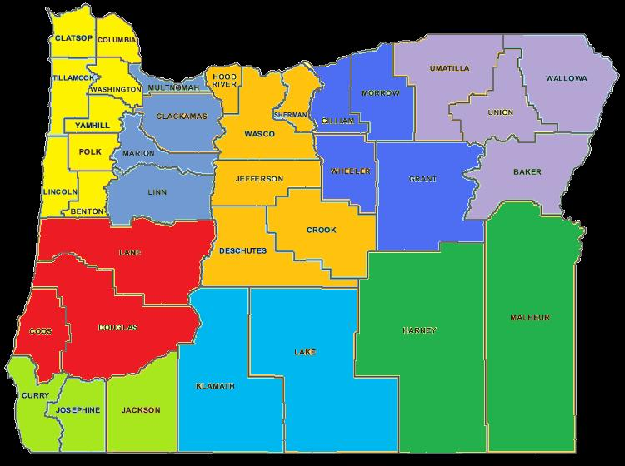
The completed application must be submitted to Oregon Volunteer Firefighters Association via email: ovfa@ovfa.org or Mailed to 1284 Court Street, Salem, Oregon 97301 by 5pm on May 31st, 2013. Individual applicants will not be accepted if not completed and received by deadline.
Region applying for:
1 2 3 5 4

9 6
8 7
Region 1 Region 2 Region 3

Region 4 Region 5 Region 5

Region 7 Region 8 Region 9

Name:

Address:

City, State & Zip: , ,

Home Phone: ( ) - Cell Phone :( ) -

E-Mail:

Fire Department Name:

Address:

City, State & Zip : , ,

Your Position: Years of Service:

Past or Current Leadership Experience:

What does being an Ambassador mean to you?

What do you hope to bring to the Ambassador program?

What are you hoping to achieve as an Ambassador?

Department Endorsement:
[Department name] endorses [Name of Applicant] for the position of Ambassador with Oregon Volunteer Firefighters Association.
1

Chief Officers Name Position

Signature Date / /

Please attach a letter of recommendation from Fire Chief and Association President

Signature Date / /

